

*SAGE Video* is a series of subject video collections, delivering educational and research-oriented video, to help you delve deeper into your topics of interest!

Use this platform discovery map to learn more about the platform in relation to a topic or concept that you’re currently studying. There is a model completed overleaf: use this as an example to guide you as you complete your own.

**Let’s get started!**

**What are you currently studying or researching?**

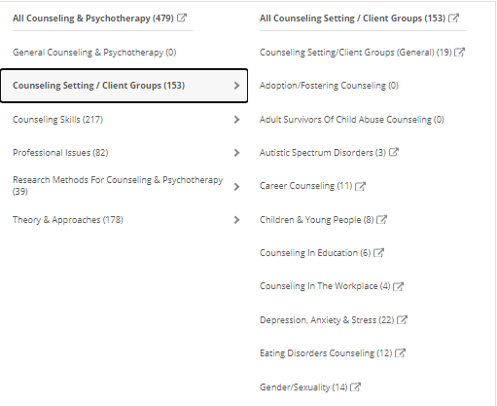

You can explore more of our training resources [**here**](https://uk.sagepub.com/en-gb/eur/training-resource-centre).

**Run a search for your chosen topic. What key word search terms did you use? Could you apply any filters?**

**Open one of the videos that looks interesting to you and note the title and video type.**

**Does the ‘Browse by Discipline’ menu have a topic, and sub-topic in the subject taxonomy, of interest to you?**

**How many videos are showing in your results list? How has ‘Browse by Discipline’ helped you?**

**At your institution, who could support you as you continue to enhance your knowledge and skills on this topic?**

**What do you like about this video? Has it helped you understand your chosen topic?**

**Where can you find the icons for you to cite, share and add this video to a list?**



Platform discovery map: example

**Let’s get started!**

**What are you currently studying or researching?**

*Therapeutic techniques, and working with children and young people*



**At your institution, who could support you as you continue to enhance your knowledge and skills on this topic?**

*My lecturers. We all attended a library skills workshop at the start of the semester, so I might go and see him to see if he can help me find any other resources for the presentation*

You can explore more of our training resources [**here**](https://uk.sagepub.com/en-gb/eur/training-resource-centre).

**Does the ‘Browse by Discipline’ menu have a topic, and sub-topic in the subject taxonomy, of interest to you?**

*Counseling & Psychotherapy > Counseling Setting/Client Groups > Children & Young People*

**How many videos are showing in your results list? How has ‘Browse by Discipline’ helped you?**

*8. The menu helped me to get to videos which will be useful without running my own search. A couple of these I can see will be relevant for my upcoming group presentation!*

**What do you like about this video? Has it helped you understand your chosen topic?**

*This documentary goes in-depth to examine legal and ethical considerations when counselling children and young people, and refers to relevant legislation, research and case studies to highlight key points. At the end of the documentary, there are 3 case studies which raise practical examples, which raise different issues, which would be a good way to generate a discussion after our group presentation*

**Where can you find the icons for you to cite, share and add this video to a list?**

*Underneath the video transcript – need to create my profile later!*

**Run a search for your chosen topic. What key word search terms did you use? Could you apply any filters?**

*I ran a search for ‘teenagers OR adolescents AND therapy’, using Boolean operators to provide more focused results, shown to us in a library skills workshop. I unselected the ‘Chapters/Entries/Segments’ filter to get a more manageable number of results*

**Open one of the videos that looks interesting to you and note the title and video type.**

[***A Confidential Space***](http://sk.sagepub.com/video/a-confidential-space?fromsearch=true) *(Documentary)*