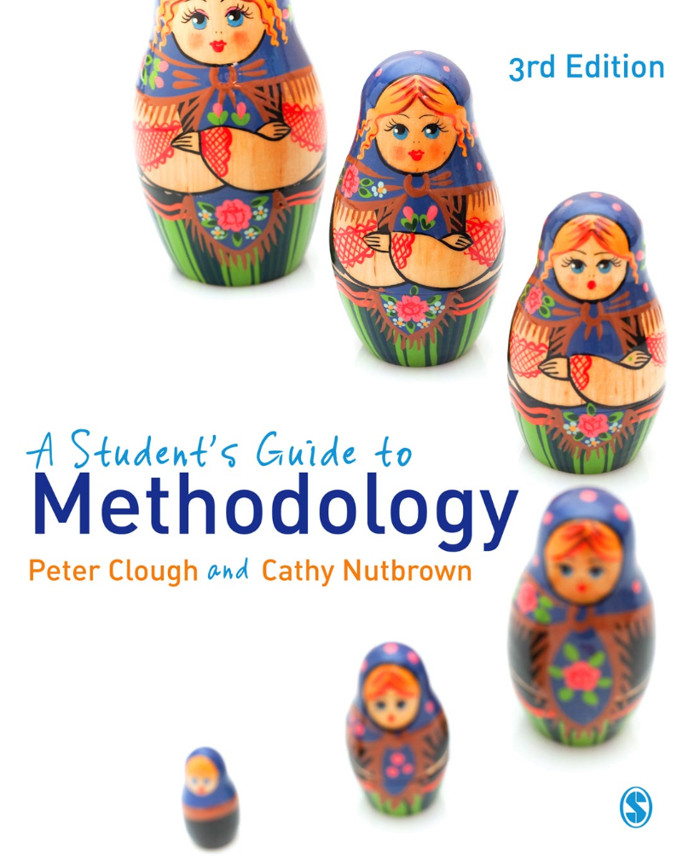
Research Planning Audit

Name........................................................................................................................
Date................................................................

What is the topic of my research? | At this stage the topic can be fairly broad. In choosing a topic bear in mind that social research sets out to achieve something. Does your topic enable you to make a difference to something or someone?
Why have I chosen this topic? | Previous research (the literature)  Have you reviewed the literature sufficiently to know where your chosen topic is positioned within the field? Which particular literature has stimulated your choice of topic?  Professional relevance (my current work)  Are there particular personal/professional or policy contexts which simulate this research? What will your study achieve in this respect?  Other reasons (such as ...)  Is the study commissioned by funders or an agency/employer paying your course fees? If so clarity about this is important. Do you still need to identify other stimuli and a research/professionally related rationale? Does your reason for choice of topic seem sufficient to sustain you through to completion of the study?
Are my reasons  good enough? | Yes, because ...  Interrogate your reasons for your above choice. Check that they are good enough reasons to proceed.  No, because ...  Nothing is perfect. Even if you’re satisfied with part of your rationale you may still have to manage elements which are not so good/ Be clear about the negative aspects and decide whether the ‘pros’ outweigh the ‘cons’.
What are my research questions? | State your research questions clearly and precisely. Remember the Russian doll principle and the ‘Goldilocks’ test. Do your research questions stand up?  1.  2.  3.  Are there more?  Be clear about how many research questions you are addressing. Keep control of your study. If there are more than three questions state them as clearly as you can at the outset.
Where do these  come from? | (Literature, practice, other? ...)  Identify the relationship between your questions and existing work in the field as well as professional stimuli.
Can I justify the research questions? How can I do this? | Draw on your research journal, the literature and your professional/personal contexts to write a strong justification for each of your research questions. If you find it difficult or impossible to justify a question then consider revising or rejecting it.
Where will I do the research? | Practical questions are important. Choose a location where you will be able to respond to your research questions. If you have to make changes due to the setting you choose be clear that you want to change your research in this way.  If you are not content to change your research you may need to change your research setting.
Have I negotiated access to the research setting? How? What? | Be clear with everyone involved what access you have negotiated. Ensure that key people know about your work and that you understand the conditions under which access has been granted. If you are carrying out your research within your own professional context ensure that you are clear about any boundaries between research and professional work, the ethics of your role as researcher, and the expectations and understandings of others working within the setting.
When will I do the research? Is my timetable  realistic?  What methods will I use to investigate the research questions? | Create a timetable – to suit you, your academic study plan and your research participants. Check out your timetable – are your plans achievable? At this point – think about the four forms of ‘Radical Enquiry’ Radical looking, Radical listening, Radical reading and Radical questioning.  Remember that methods are created for particular research tasks, not simply lifted from a research methods manual and replicated. Your study is unique and your research methods will be moulded to enable you to respond to your research questions.
How can I justify these methods? | This is a crucial question. Research methods are justifiable only in so far as they help you to respond to the research questions. Do your chosen methods help you to do that? What have other researchers done in the past? How have other similar issues been investigated? Does the literature help your justification? Will your methods enable you to conduct a study which is persuasive, purposive, positional and political?
What are the ethical considerations? How will I address these? Does the study need ethical approval? | This is a further question of justification. As you judge it at this point – can you see any danger of your research doing harm to participants in the study either in the process or in its report? Have you weighed your research plan against various codes of practice for the conduct of ethical research? If you are planning to include the voices of others in your research report – do you have their permission? What guarantees have you given them?
Is there anything I need to rethink? | The topic? The methods? The timetable? The location?  Pause now and reflect on the issues raised by carrying out this planning audit. What – if anything – do you need to rethink?  Are your research questions sufficiently clear? Are they robust? Do they reflect previous research in the field?  Are your methods appropriate to the study? Will they enable you to respond to the research questions?  Can you fulfil your research plan in the timescale available?  Are you planning to locate your study in an appropriate setting?  Are you clear about any ethical considerations within your study?
Do I need to revise the research questions?  Are they clear?  Are they researchable? | In the light of the above reflection – undertake one more review of your research questions. This is an opportunity to check that your research questions are expressed in the clearest possible terms.  1.  2.  3.  (others?)
Where have I got to in my research? | Review your research journal and your research timetable to create a brief synopsis of progress to date.
What is my first/  next step? | Action! What, in the light of your research questions, your timetable and your progress, do you need to do next.
What help do I need? | You do not have to carry out the whole of your study in solitude. Make a list of those who can help you – including your supervisor – and be sure to contact them when you need them.
Who do I call? | Do you have all the telephone numbers you need?  Check that this includes the library and details of how to renew loans remotely.
